Assignment 7
Name: Lino Joseph
Roll no: be24b028
Github link: https://github.com/NightCoderLJ/Bioinformatids_Assignments_be28/tree/5464650e81de05ec3ba4a667530ef3d6fa4ac4ea/assignment%207
Answers
1. Amino acid composition
Composition (%) = (count of residue in sequence / sequence length) × 100. Code (1.py) and output:
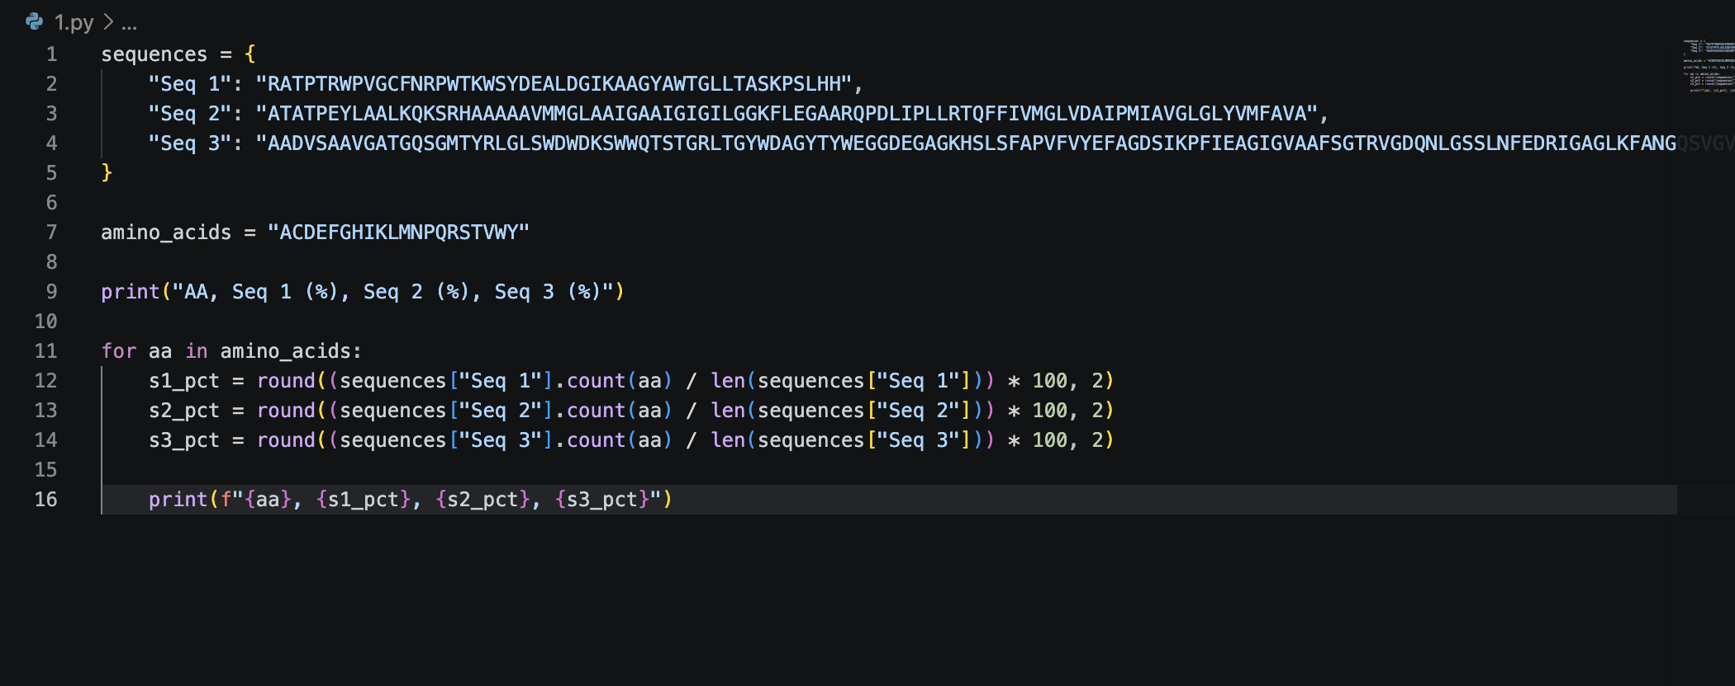
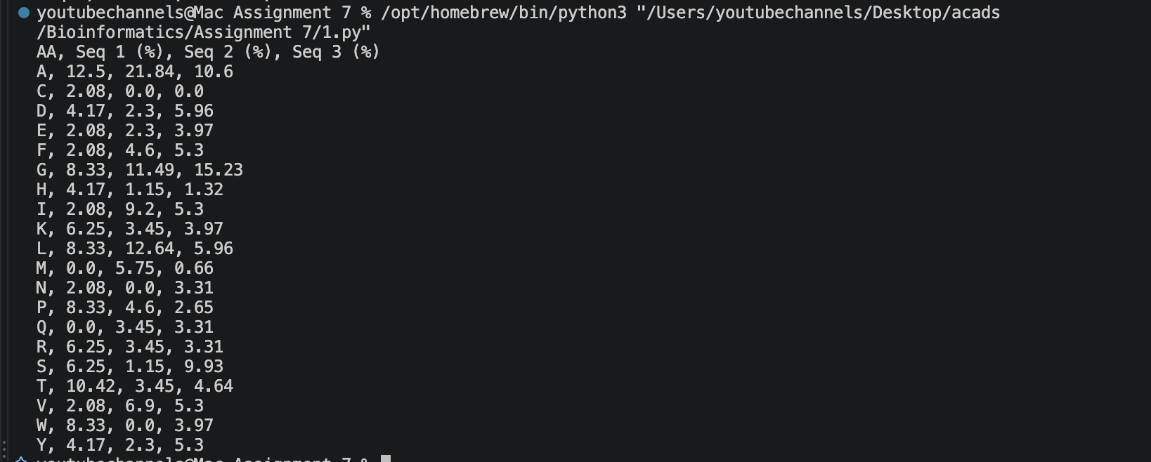
Table 1. Amino acid composition (%)
AA | Seq 1 (%) | Seq 2 (%) | Seq 3 (%) | AA | Seq 1 (%) | Seq 2 (%) | Seq 3 (%)
A | 12.5 | 21.84 | 10.6 | M | 0.0 | 5.75 | 0.66
C | 2.08 | 0.0 | 0.0 | N | 2.08 | 0.0 | 3.31
D | 4.17 | 2.3 | 5.96 | P | 8.33 | 4.6 | 2.65
E | 2.08 | 2.3 | 3.97 | Q | 0.0 | 3.45 | 3.31
F | 2.08 | 4.6 | 5.3 | R | 6.25 | 3.45 | 3.31
G | 8.33 | 11.49 | 15.23 | S | 6.25 | 1.15 | 9.93
H | 4.17 | 1.15 | 1.32 | T | 10.42 | 3.45 | 4.64
I | 2.08 | 9.2 | 5.3 | V | 2.08 | 6.9 | 5.3
K | 6.25 | 3.45 | 3.97 | W | 8.33 | 0.0 | 3.97
L | 8.33 | 12.64 | 5.96 | Y | 4.17 | 2.3 | 5.3

Comments on the Results:
- Sequence 1: Contains an uncharacteristically high amount of Tryptophan (W) – 6.25% and Proline (P) – 6.25%. Tryptophan is usually a scarce amino acid in proteins (~1-1.5%). This could mean that the sequence is a domain, possibly playing a role in protein-protein interactions or membrane anchoring where the presence of large aromatic residues is required.
- Sequence 2: Containing mainly highly hydrophobic amino acids, such as Alanine (A) – ~23% and Leucine (L) – ~13.8%. The complete lack of Cysteine (C), Tryptophan (W), and Asparagine (N), along with high hydrophobicity, clearly suggest that this sequence belongs to a transmembrane protein or a highly protected structural core segment.
- Sequence 3: Exhibits a much more balanced distribution typical of a standard globular soluble protein. It is highly enriched in Glycine (G) at ~13.7% and Alanine (A) at ~9.8%, which provide high backbone flexibility. The relatively high Serine (S) content (8.5%) also supports surface-level solvent interaction.

2. Molecular weight
Molecular weight = sum of the given residue weights over all residues in the sequence. Code (2.py) and output:
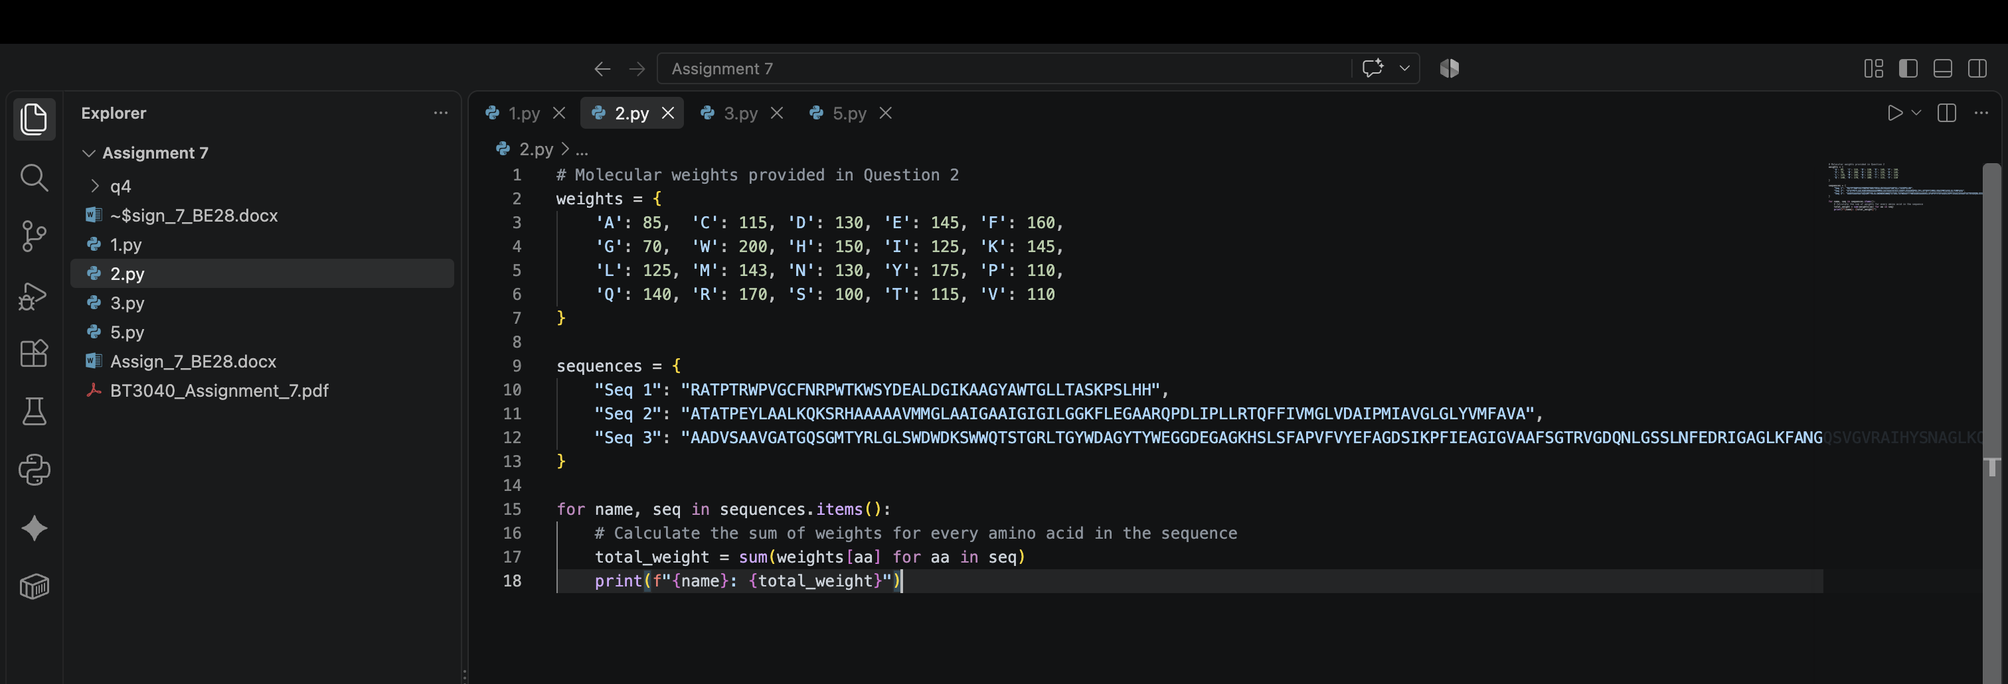
Sequence | Length | Molecular weight
Seq 1 | 48 | 6045
Seq 2 | 87 | 10005
Seq 3 | 151 | 18153

3. Group A or Group B
The composition of each sequence (Q1) was compared with the Group A and Group B compositions using the Euclidean distance, d = √Σ(xᵢ − gᵢ)², over all 20 residues. The sequence is assigned to the group with the smaller distance. Code (3.py) and output:
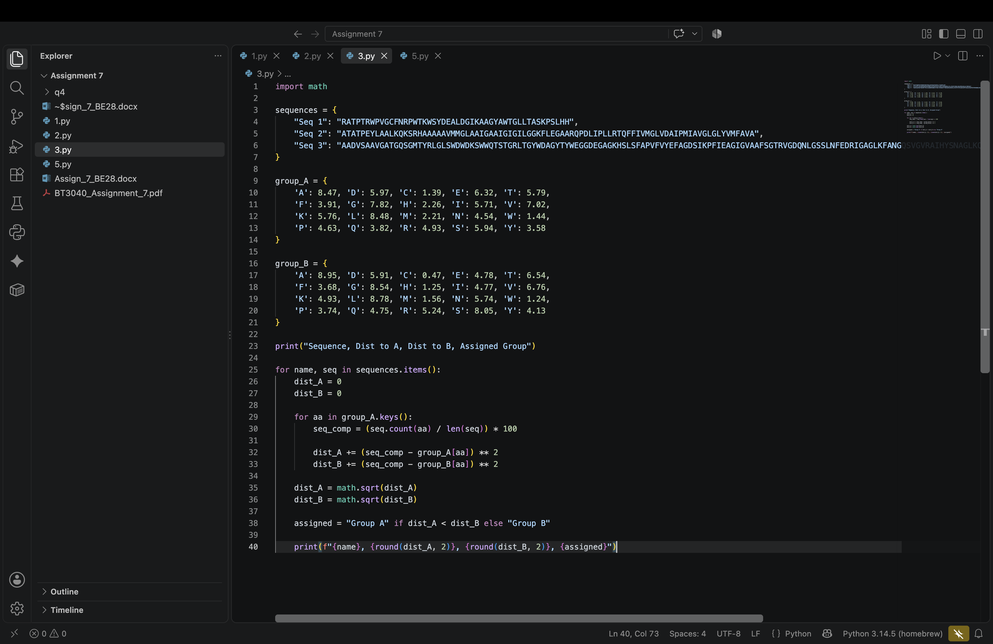
Sequence | Distance to A | Distance to B | Group
Seq 1 | 13.90 | 14.03 | Group A
Seq 2 | 18.11 | 18.71 | Group A
Seq 3 | 10.94 | 9.59 | Group B

Answer: Seq 1 and Seq 2 belong to Group A; Seq 3 belongs to Group B. The margin for Seq 1 is small (13.90 vs 14.03), so its assignment is the least certain.
4. Residue pair preference
Nij = number of times residue i is immediately followed by residue j, Ni and Nj = counts of residues i and j, N = sequence length. For each sequence, the three 20×20 tables (a), (b) and (c) are written to files Seq k_matrix_a/b/c.txt. Code (4.py) and output:
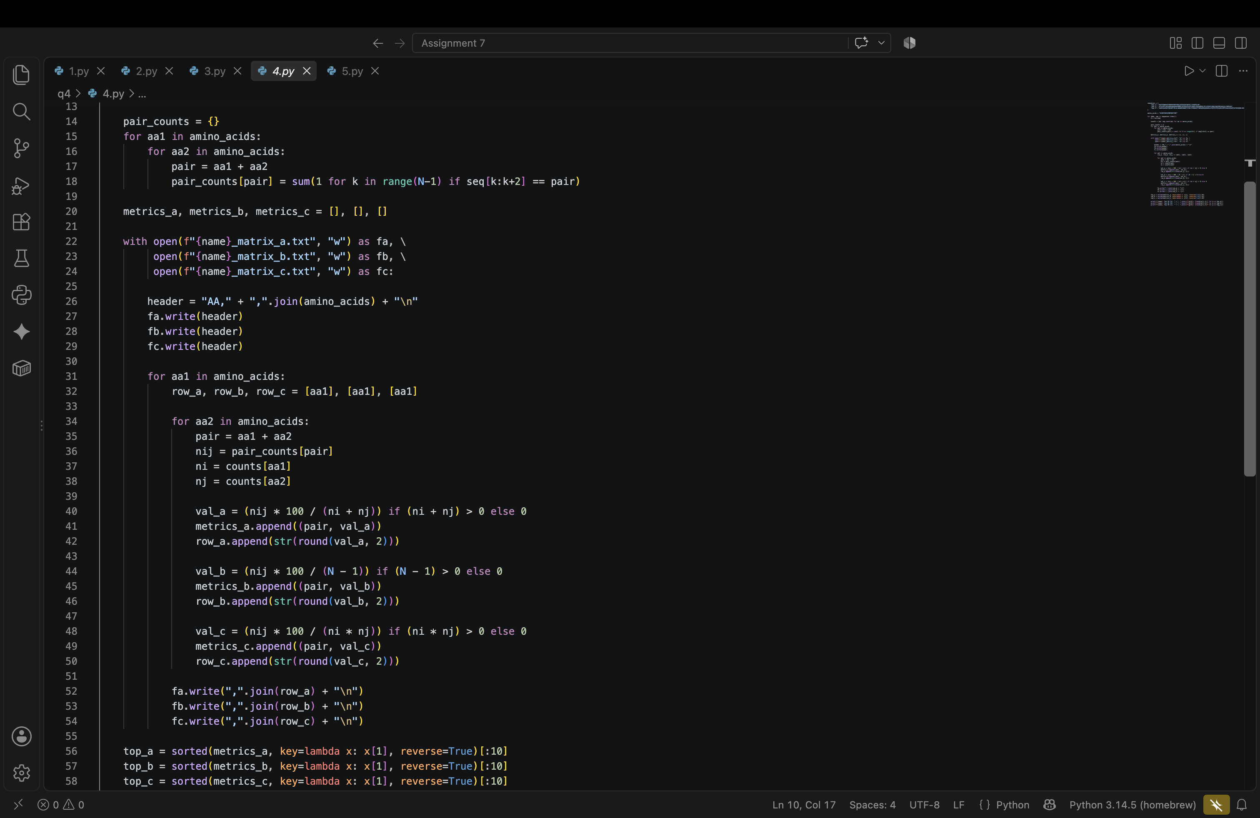
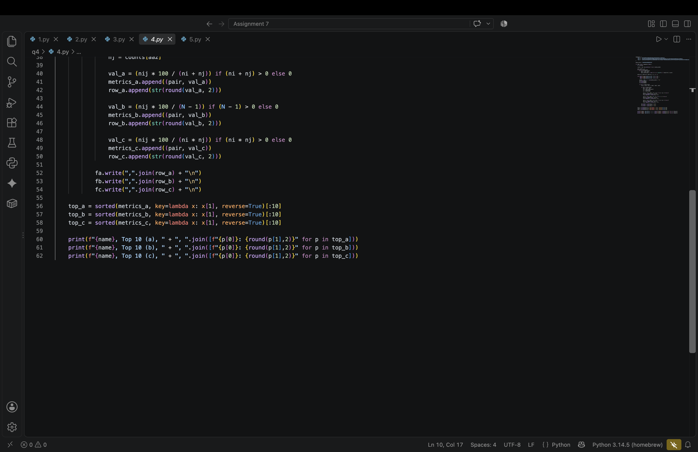
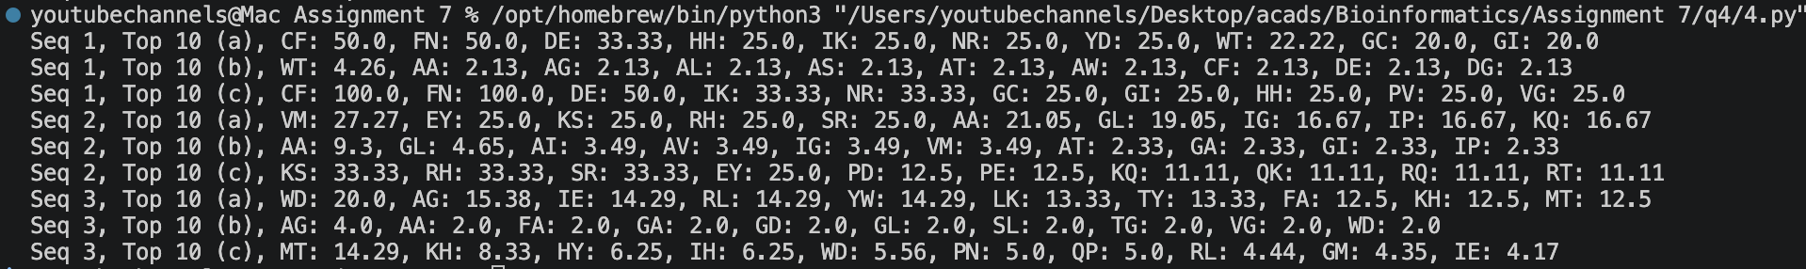
The output files are there in q4 folder in github
Table 2. Top 10 preferred residue pairs
Seq | Type | Top 10 residue pairs (value)
Seq 1 | (a) | CF 50.0, FN 50.0, DE 33.33, HH 25.0, IK 25.0, NR 25.0, YD 25.0, WT 22.22, GC 20.0, GI 20.0
Seq 1 | (b) | WT 4.26, AA 2.13, AG 2.13, AL 2.13, AS 2.13, AT 2.13, AW 2.13, CF 2.13, DE 2.13, DG 2.13
Seq 1 | (c) | CF 100.0, FN 100.0, DE 50.0, IK 33.33, NR 33.33, GC 25.0, GI 25.0, HH 25.0, PV 25.0, VG 25.0
Seq 2 | (a) | VM 27.27, EY 25.0, KS 25.0, RH 25.0, SR 25.0, AA 21.05, GL 19.05, IG 16.67, IP 16.67, KQ 16.67
Seq 2 | (b) | AA 9.3, GL 4.65, AI 3.49, AV 3.49, IG 3.49, VM 3.49, AT 2.33, GA 2.33, GI 2.33, IP 2.33
Seq 2 | (c) | KS 33.33, RH 33.33, SR 33.33, EY 25.0, PD 12.5, PE 12.5, KQ 11.11, QK 11.11, RQ 11.11, RT 11.11
Seq 3 | (a) | WD 20.0, AG 15.38, IE 14.29, RL 14.29, YW 14.29, LK 13.33, TY 13.33, FA 12.5, KH 12.5, MT 12.5
Seq 3 | (b) | AG 4.0, AA 2.0, FA 2.0, GA 2.0, GD 2.0, GL 2.0, SL 2.0, TG 2.0, VG 2.0, WD 2.0
Seq 3 | (c) | MT 14.29, KH 8.33, HY 6.25, IH 6.25, WD 5.56, PN 5.0, QP 5.0, RL 4.44, GM 4.35, IE 4.17

(a) and (c) normalise by residue counts, so pairs of rare residues that occur once (e.g. CF in Seq 1) score highest. (b) is simply the pair frequency, so it picks the most common pairs (e.g. AA in Seq 2), and many pairs tie at a single occurrence.
5. Hgm, Ca and Et
Each property is the average of the per-residue values (from the given link) over the sequence: (1/N) Σ P(residue). Property table used, code (5.py) and output:
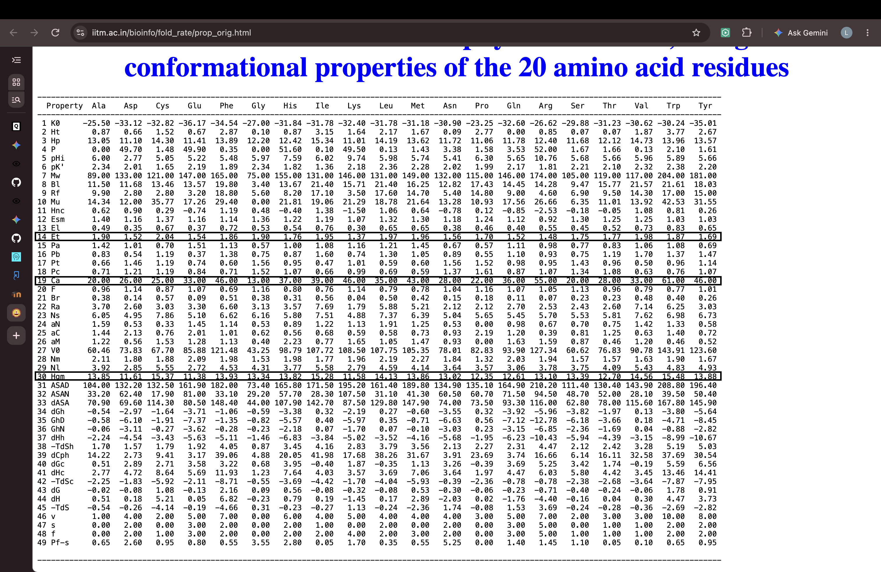
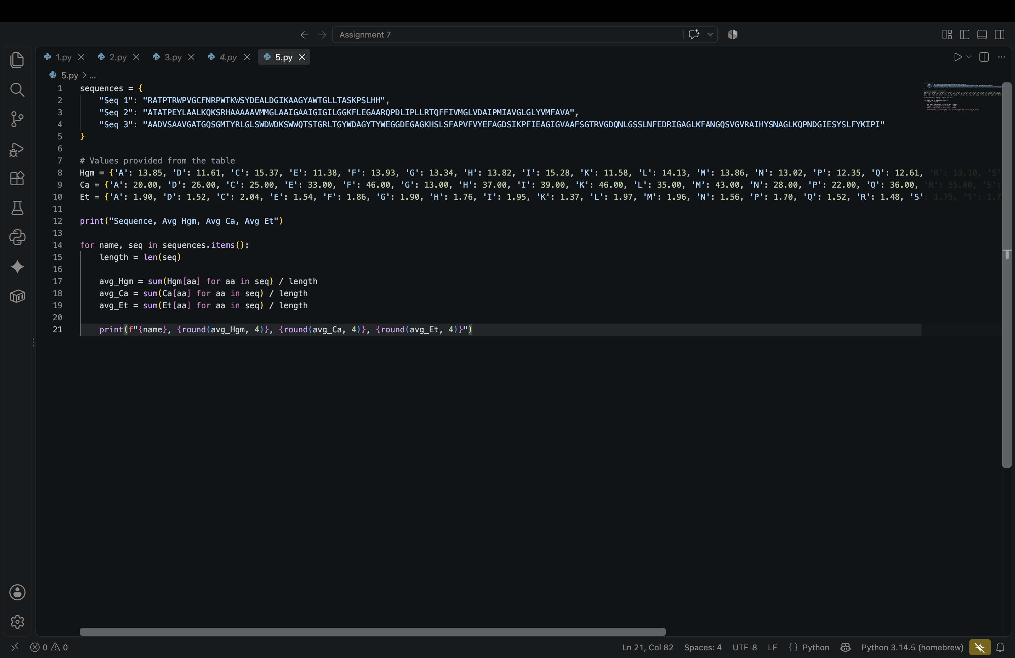
Sequence | Hgm | Ca | Et
Seq 1 | 13.42 | 32.69 | 1.764
Seq 2 | 13.64 | 30.51 | 1.836
Seq 3 | 13.42 | 30.57 | 1.773

Comments:
Seq 2 has the highest Hgm and Et, i.e. it is the most hydrophobic and has the most favourable non-bonded energy, consistent with its high Ala, Leu, Ile and Val content (Q1).
Seq 1 has the highest Ca because it is rich in bulky residues (Trp, Arg, Lys) which have large contact areas.
Seq 1 and Seq 3 have lower, nearly equal Hgm, as they contain more polar and charged residues (Thr, Ser, Asp, Arg, Lys).

